Investigating Bombus borealis Distributions, Present and Future

Jake Gostisha, Dani Millin, Tessa Singer

**Abstract**

Bombus borealis, more commonly known as the bumblebee, is an important pollinator of its ecosystem, helping to cross-pollinate the flowering plants of its habitat. Under current conditions Bombus borealis thrives in the north central region of the United States and southern Canada. Given worst case climate conditions the habitat of these bees will be displaced entirely by the year 2050 and forced to find more hospitable living conditions further north. This result could be dangerous to the survival of the bumblebee as this rapid displacement would be too fast to adapt to the differing flora of northern Canada. This would leave the bee without a dependable food source and also affect the plant populations that currently depend upon the bee for ecosystem services such as cross pollination.

**Key Words**

Bombus borealis, Climate Change, Species Distribution, Bumblebee

**Introduction**

The genus Bombus, commonly referred to as bumblebees, are important pollinators in North American ecosystems. Pollinators forage from flower to flower to collect nectar and pollen to feed their colony. In collecting food for the colony the bumblebees are also spreading the pollen, which fertilizes the seeds of these plants and allows the plants to reproduce. Bumblebees not only assist in plant pollination, but also impact the quality of offspring produced by plants. In fact, a recent study conducted by researchers at the Andalucía Institute of Investigation and Education of Agriculture and Fishing (IIFAP), found that commercial cultivars of sweet pepper visited by bumblebees produced both larger and heavier fruits than cultivars that were not visited by bumblebees (1). Clearly, animal pollinators like the bumblebee play a major role in plant pollination, making their survival vital to ecosystems of the Northern Hemisphere. Unfortunately, bumblebee populations have been threatened in recent years. Most notably, climate change has been identified as one such threat (2).

Climate change is a threat to many species across the globe. As average temperatures continue to increase over the years, species ranges are beginning to shrink and move north, as well as shift the timing of their life cycles. Bumblebees can be affected by global warming directly, or indirectly via their food plants, or even via their nest sites (3). Bumblebee nest sites can be affected by natural disasters due to the changing climate, such as flooding. Global warming may also indirectly affect bumblebees due to a disturbance of native plants that bumblebees rely on as a food source. Warming temperatures can change the time at which flowers bloom and have the ability to be pollinated. Because of the valuable ecological services provided by bumblebees to both plants and humans (2), the disappearance of bumblebees could be catastrophic. The consequences of declining or even disappearing bumblebee distributions would be devastating for plant populations, and by extension whole ecosystems, not to mention our food supply (2).

Much of the research conducted on the effects of climate change on pollinator distributions, such as the bumblebee, has operated on a global scale. As a result, there is a lack of knowledge of the effects of climate change on bumblebees on a smaller scale, especially of bumblebee distribution in the Northeastern regions of North America and Southern region of Canada.

Bearing this information in mind, we seek to investigate possible relationships between bumblebee range distribution in Northeastern North America and Southern Canada, and climate change. Our research seeks to answer two questions: How has climate change impacted range distribution of bumblebees in these regions? What might future range distribution look like if climate change continues at a consistent rate? We predict that bumblebee range distributions in these regions will initially increase as temperatures rise, but will eventually decrease as temperatures reach uninhabitable heights, leading to a significant decrease in bumblebee range distribution by the year 2070.

**Methods**

Our research uses data mining, relying on data of the species Bombus Borealis, from the Global Biodiversity Information Facility (GBIF). The data set is Bombus borealis Kirby, 1837. The data spans across the upper Northeastern region of the U.S. as well as Southern Canada. A presence-absence model was used to manipulate the data mined from the database, boosted regression trees were used to produce current, future, and difference maps. We map past bumblebee range using three bioclimatic variables; bio1- the mean annual temperature, bio10- the mean temperature of the warmest quarter, and bio13- the precipitation of the wettest quarter. Future predictions for each of these variables under worst case scenario global warming conditions were then used to predict how the species distribution for Bombus borealis would change in the future. We selected these variables as the main consequence of global warming is the change in mean annual temperature, bees are most active in the summer months making the warmest quarter of interest and, finally, the flowers that bees depend upon would be affected by precipitation. Past and current bumblebee range distribution were mapped and then compared using difference maps to track changes in distribution between each time period. Past bumblebee distribution was mapped over a 50 year time span beginning in 1940 and ending in 2000.

The datasets and code supporting this article have been uploaded as part of the supplementary material.

**Results**

The maps produced for current Bombus distribution unsurprisingly show a range consistent with the map of occurrence data used to produce the range. Both the 2050 and 2070 boosted regression models show a northern movement of the distribution (Fig 1 & Fig 2). The difference maps show that current and 2050 distributions are almost completely different areas (Figure 1), while the 2070 difference maps show that there is essentially no overlap between previous habitable area and newly habitable area (Figure 2). This is a drastic change in habitat over a relatively short amount of time.

Figure 1. Current Bombus borealis distribution (a), and predicted distribution as of 2050 (b) plotted using a boosted regression tree analysis. Green areas represent areas best suited climatically to Bombus borealis. White and Red areas are least suitable. Difference map (c) shows where these distributions are unchanged (orange), where Bombus borealis is predicted to live where it did not before (yellow), and where Bombus borealis is no longer likely to inhabit (red).

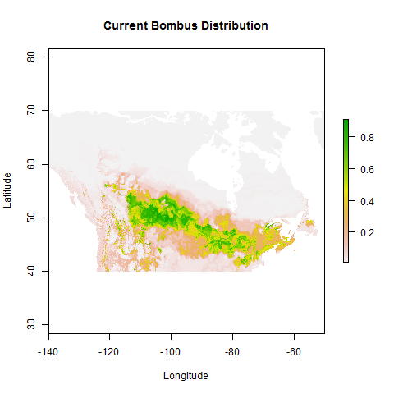

(a)

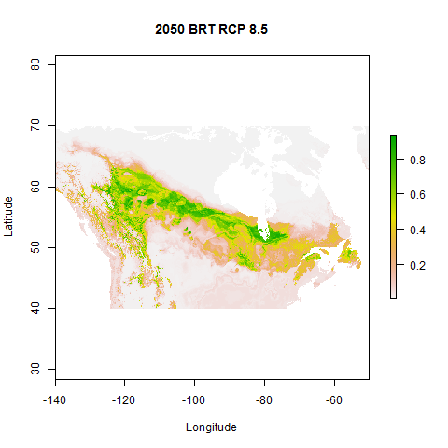

(b)

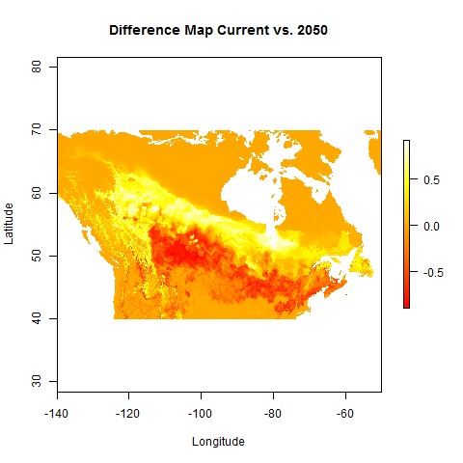

(c)



(a)

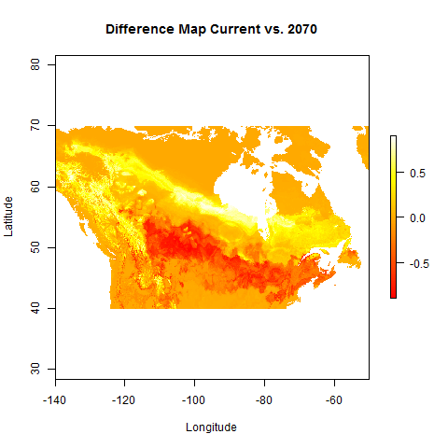

(c)

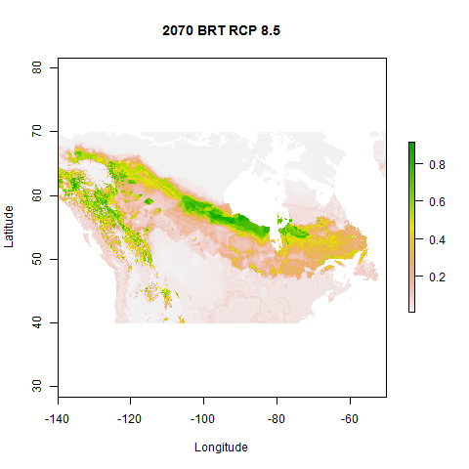

(b)

Figure 2. Current Bombus borealis distribution (a), and predicted distribution as of 2050 (b) plotted using a boosted regression tree analysis. Green areas represent areas best suited climatically to Bombus borealis. White and Red areas are least suitable. Difference map (c) shows where these distributions are unchanged (orange), where Bombus borealis is predicted to live where it did not before (yellow), and where Bombus borealis is no longer likely to inhabit (red).

In analyzing the relative influence of each climatic variable on the species distribution, we found that bio10 or the mean temperature of the warmest quarter had the most influence on the distribution of Bombus borealis. The second most influence was held by bio1 or the mean annual temperature, followed by bio13 or the precipitation of the wettest month (Figure 3). The boosted regression yielded an AUC score of 0.896.

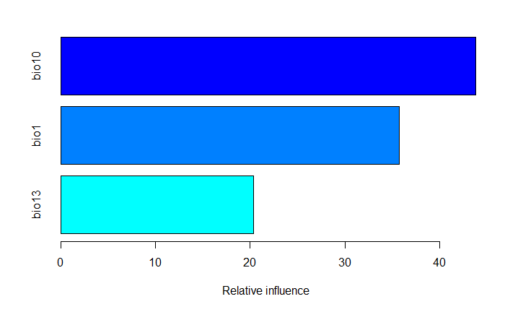

Figure 3. Relative importance of each bioclimatic variable considered in the boosted regression tree model. Bio 10 represents the mean temperature of the warmest quarter, bio 1 is the mean annual temperature, and bio 13 is the precipitation of the wettest month.

**Discussion**

Climate change may not be the only driver in the decline of bumblebees. Disease can quickly wipe out entire colonies at a time. Furst et al., 2014 found that two pathogens which infect honeybees have crossed over into populations of wild bumblebees(4). The two diseases Furst looked at were deformed wing virus (DWV) which causes wing and abdominal deformities in honeybees, especially those hosting the blood-sucking Varroa mite, and Nosema ceranae, a fungus that causes intestinal inflammation among other problems. Both pathogens are known to have been major players in the collapse of honeybee colonies in North America and Europe (5). Changing agricultural policy and practices have often been identified as driving the land use changes that are also likely to have contributed substantially to many bumblebee declines (3). The removal of orchards and the improvement of grasslands with the use of fertilizers are some of the more harmful changes of land use. As the warming of the climate is affecting the spatial patterns of bumblebees, it is even more important to assess other aspects that could be affecting the decline of Bombus Borealis.

Climate change is not only directly affecting bumblebees, but it is also indirectly affecting them. The warming climate can alter the time at which flowering plants blossom. Plants and pollinators use different genetic and environmental cues to manage the time at which they are ready to blossom and ready to pollinate. An example of this is the pollinator emerging in response to air temperature, while the plant flowers in response to snow melt (6). When the hive is below 93 degrees fahrenheit, the bees cluster in the hive to keep the queen bee and the larvae at 93 degrees (6). If the plant flowers before the hive is at 93 degrees, the bees will not be pollinating the plants which have already flowered. The unsynced timing between the plant and the pollinator will lead to colony loss and potentially a decrease in plant abundance.

The decline of bumblebees may result in devastating consequences. Pollen from flowering plants are most often moved by bees. Around two-thirds of the food we eat, by weight, comes from staple crops such as rice, wheat and maize that are pollinated by wind, not insects. The remaining one-third, which is pollinated by insects, includes fruits and vegetables, nuts, many herbs and spices, coffee and chocolate; a diet free of insect-pollinated foods would therefore be short on many nutrients and altogether pretty boring (7). There are many threatening factors fueling the decline of bumblebees. Our study evaluated the factor of global warming, and how it both directly and indirectly affects bumblebees. Our results from future climate predictions of warmer temperatures suggests that bumblebees will begin to move north. The spatial models show Bombus borealis moving north almost to the point that bumblebees will no longer exist in the continental U.S. by 2070.

To combat the declining distributions of the bumblebee, we first need to further study the bumblebee community. The ratio in which worker bees forage is often the same spatial scale that many ecological and climate models use to predict ecosystems’ responses to climate change. This ratio also matches the spatial scale of satellite images of vegetation collected by NASA’s Terra and Aqua satellites (6). Understanding the inner workings of bumblebees and their hives would allow us to investigate a more dynamic picture of how plants and bumblebees are affected by climate change. Having such data would allow us to develop strategies to combat the harmful changes in interactions between plants and bumblebees that our model predicts due to the warming climate.

**Acknowledgements**

The authors would like to thank Israel Del Toro for his help and guidance in modeling using R.

**References**

1. Roldán Serrano A, Guerra-Sanz JM. Quality fruit improvement in sweet pepper culture by bumblebee pollination. Sci Hortic (Amsterdam) [Internet]. 2006 Oct 9;110(2):160–6. Available from: http://www.sciencedirect.com/science/article/pii/S030442380600272X

2. Kerr JT, Pindar A, Galpern P, Packer L, Potts SG, Roberts SM, et al. Across Continents. 2015;349(6244):177–80.

3. Williams PHPHPH, Osborne JL. Bumblebee vulnerability and conservation world-wide. Apidologie [Internet]. 2009;40(3):367–87. Available from: http://www.springerlink.com/content/p1367u716335h47w/abstract/%5Cnhttp://www.springerlink.com/content/p1367u716335h47w/fulltext.pdf%5Cnhttp://www.apidologie.org/10.1051/apido/2009025%5Cnhttp://dx.doi.org/10.1051/apido/2009025

4. Fürst M a., McMahon DP, Osborne JL, Paxton RJ, Brown MJF. Disease associations between honeybees and bumblebees as a threat to wild pollinators. Nature [Internet]. 2014;506(7488):364–6. Available from: http://www.ncbi.nlm.nih.gov/pubmed/24553241%5Cnhttp://www.nature.com/doifinder/10.1038/nature12977

5. Holland JS. Bad News for Bumblebees: Disease Spreading From Honeybees [Internet]. National Geographic. 2014 [cited 2017 Mar 14]. Available from: http://news.nationalgeographic.com/news/2014/02/140227-bumblebee-honeybee-disease-declines-science-pollinators-disease/

6. Lindsey R. Buzzing about Climate Change [Internet]. Earth Observatory. 2007 [cited 2017 Mar 14]. Available from: https://earthobservatory.nasa.gov/Features/Bees/bees.php

7. D.J.P. The decline of bees [Internet]. The Economist. 2015 [cited 2017 Mar 14]. Available from: http://www.economist.com/blogs/economist-explains/2015/09/economist-explains-2

**Data Set**

iNaturalist.org: iNaturalist Research-grade Observations, 2016-10-05.   
Accessed via http://www.gbif.org/occurrence/1315049310 on 2017-03-15

**R Citations**

R:

R Core Team (2016). R: A language and environment for statistical

computing. R Foundation for Statistical Computing, Vienna, Austria.

URL https://www.R-project.org/.

gbm package:

Greg Ridgeway with contributions from others (2015). gbm:

Generalized Boosted Regression Models. R package version 2.1.1.

https://CRAN.R-project.org/package=gbm

raster package:

Robert J. Hijmans (2016). raster: Geographic Data Analysis and

Modeling. R package version 2.5-8.

<https://CRAN.R-project.org/package=raster>

maptools package:

Roger Bivand and Nicholas Lewin-Koh (2016). maptools: Tools for

Reading and Handling Spatial Objects. R package version 0.8-40.

https://CRAN.R-project.org/package=maptools